/\*Ashok Rathod

IPBC Orientation lab

7.9.19 \*/

1. Answer the questions above.

Homework – Write no more than 1 page on the following.

1. How motivated are you?

I have done many assignments in sql class and practice them which provides me great motivation to become software developer in growing data field.

I am well motivated to achieve my goal to become data engineer with doing this course. The course is intensive and that motivated me to join IPBC. Hard work always pays off.

1. What getting a job in this field means to you/family?

Getting a job in this field means to me/family mean a lot to me. It will provide financial safety and support to my family. I am from IT background, I have done bachelor and masters in IT and I was seriously looking to get into career in data field by specific course where I can get good understanding and increase my knowledge. I have waited for 3 years to get job in IT field and I also tried lot to get that but lake of experience was the big factor for not getting job.

1. What is your intended work ethic until you are placed in the field?
2. Practicing Punctuality

-- Set daily time frame of 7-8hr a day to start task at specific time till end of specific task.

1. Using Time Wisely

-- I will use time very wisely to complete my class work on time as per scheduled.

1. Staying Balanced

--Will make my daily routine specific so I can balance my IPBC class work and personal life.

1. Why you? What separates you from everyone else who wants a successful career.

* I trust myself and have faith to success in DATA field career. I am hardworking and dedicated till I get success, I have passion to solve problem or roadblocks for my success.

2. Submit the link to your video as part of your homework.

-- <https://app.colaberry.com/app/ipbc/videos?user=31221&category=10>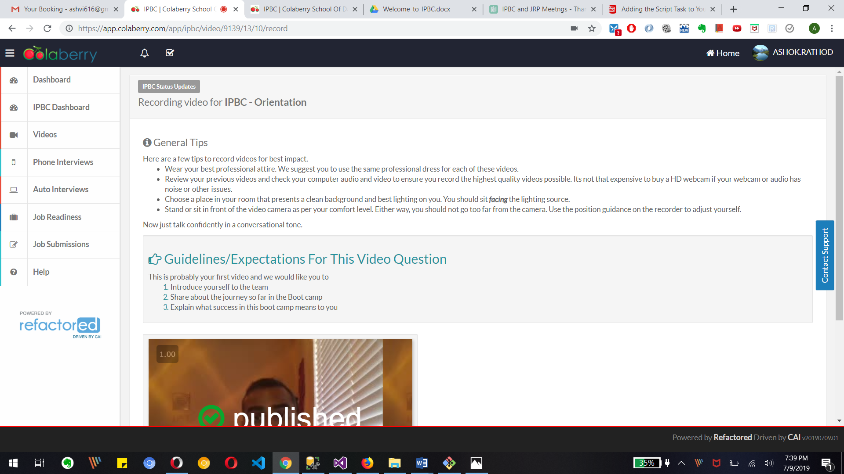

3. Watch, Comment &amp; take screenshots of your comments from 3 other videos in the same

section. Comments must be 20+ characters. Leave comments based on presentation,

delivery and/or technical details. Your critiques will help you be more conscious of your

own videos.

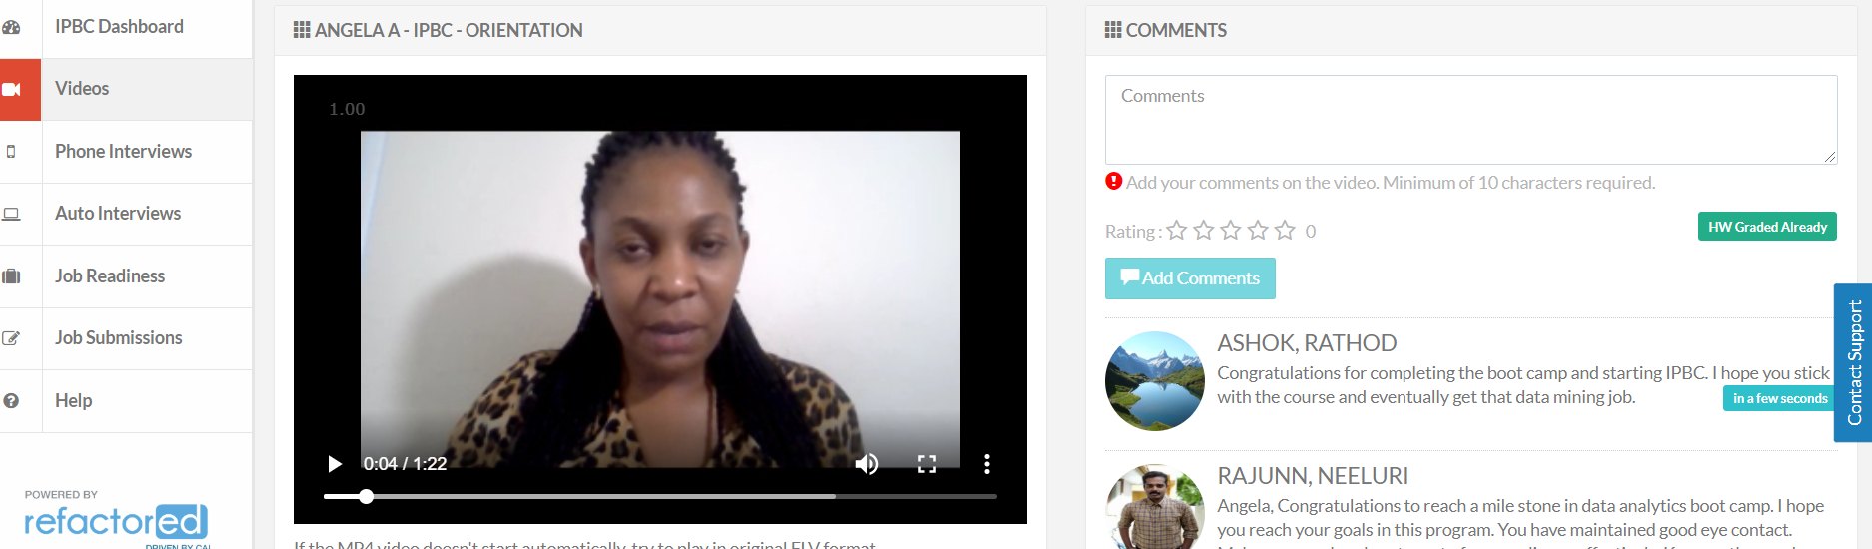

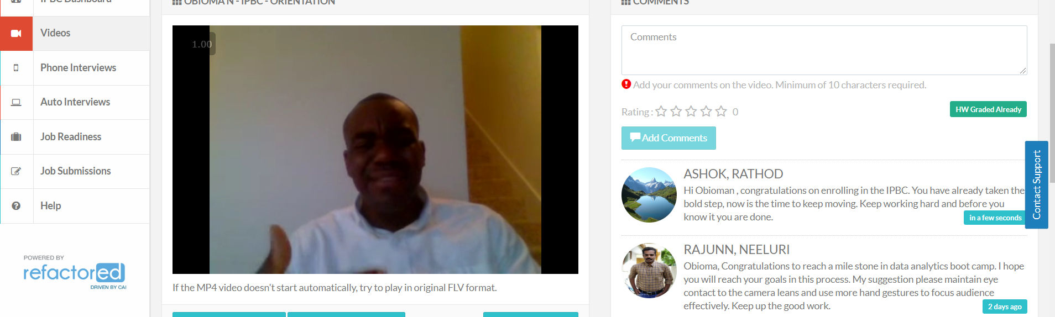

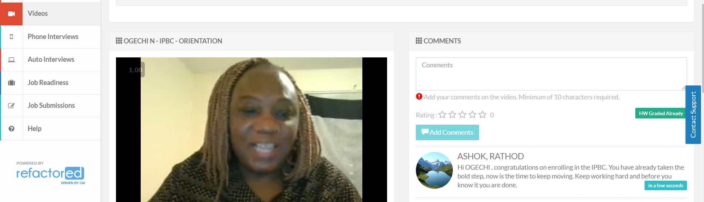

4. Book an IPBC approval meeting by using the link above.

